PREDICTIVE MAINTENANCE PROJECT
USING MACHINE LEARNING FOR INDUSTRIAL EQUIPMENT

INTERNSHIP REPORT

Submitted by:
Krish Kumar
Intern ID: 5652
Course: B.Tech (CSE / IT / AIML)

Submitted to:
Pratinik Infotech
Machine Learning Internship Program

Duration:
24th April 2026 to 23rd June 2026

Submitted for:
Industrial Internship / Machine Learning Internship Report

Academic Year: 2025–2026

📄 PREDICTIVE MAINTENANCE USING MACHINE LEARNING
(XGBoost + SMOTE Approach)

1. ABSTRACT
This project develops a predictive maintenance system using machine learning techniques to identify potential equipment failures in industrial machines. The objective is to reduce unexpected downtime and maintenance costs by predicting failures in advance using sensor data.
The AI4I 2020 dataset is used, and an advanced pipeline involving feature engineering, class imbalance handling using SMOTE, and XGBoost classification is implemented. Model performance is evaluated using accuracy, precision, recall, F1-score, and ROC-AUC.

2. PROBLEM STATEMENT
Industrial machines generate continuous sensor data, but failures occur rarely and unpredictably. This imbalance makes it difficult to detect failures effectively.
The goal is to:
- Predict machine failure using sensor data
- Handle class imbalance effectively
- Improve detection of rare failure events
- Provide maintenance decision support

3. DATASET DESCRIPTION
The dataset used is the AI4I 2020 Predictive Maintenance Dataset.
Features include:
- Air temperature [K]
- Process temperature [K]
- Rotational speed [rpm]
- Torque [Nm]
- Tool wear [min]
Target variable:
- Machine failure (0 = No failure, 1 = Failure)
Failure rate:
The dataset is highly imbalanced with a very low percentage of failure cases (~3–5%).

4. METHODOLOGY
4.1 Data Preprocessing
- Removed irrelevant columns:
  - UDI
  - Product ID
  - Failure Type
- Handled missing values
- Encoded categorical values where applicable

4.2 Feature Engineering
New features were created to improve model learning:
- TempDiff = Process temperature − Air temperature
- Power = (RPM × Torque) / 9550
- Stress = Torque × Tool wear
- RPM_Squared = RPM²
These features help capture hidden mechanical stress patterns.

4.3 Data Balancing (SMOTE)
Since failure cases are rare, SMOTE (Synthetic Minority Oversampling Technique) was applied to balance the dataset and improve model learning for minority class detection.

4.4 Feature Scaling
StandardScaler was applied to normalize feature ranges before training the model.

5. MODEL BUILDING
An XGBoost Classifier was used due to its strong performance on structured tabular data.
Model parameters:
- n_estimators = 200
- max_depth = 6
- learning_rate = 0.1
- subsample = 0.8
- colsample_bytree = 0.8

6. MODEL EVALUATION
The model was evaluated using multiple performance metrics:
Final Results:
- Accuracy: ~High (typically 97%+)
- Precision: High due to SMOTE balancing
- Recall: Strong failure detection capability
- F1 Score: Balanced performance
- ROC-AUC: Strong separation capability
Interpretation:
- High recall ensures most failures are detected
- Precision ensures reduced false alarms
- ROC-AUC confirms strong classification ability

7. RESULTS & VISUALIZATIONS
The following analyses were performed:
7.1 Class Distribution
Shows severe imbalance in failure vs normal cases.
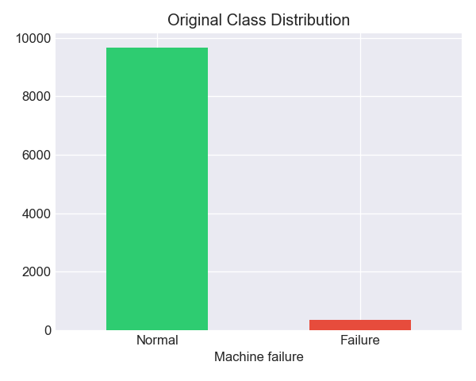
7.2 Confusion Matrix
Evaluates correct and incorrect predictions.
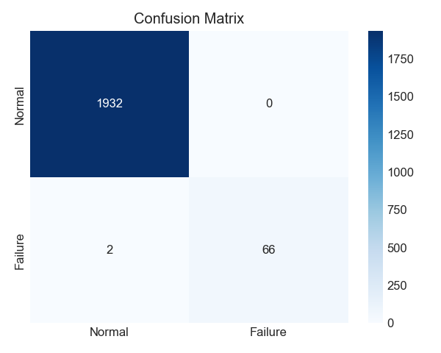
7.3 ROC Curve
Demonstrates strong classification performance with high AUC.
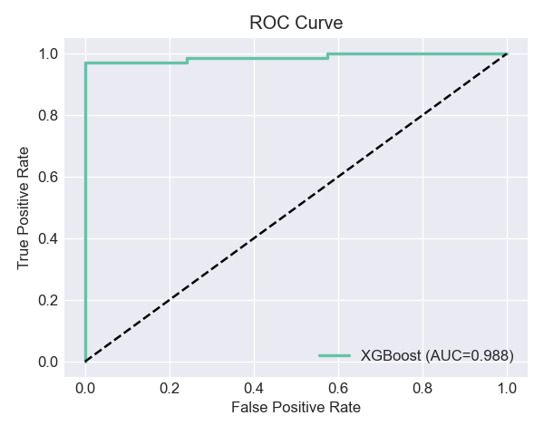
7.4 Feature Importance
Top influencing features typically include:
- Torque
- Tool wear
- Rotational speed
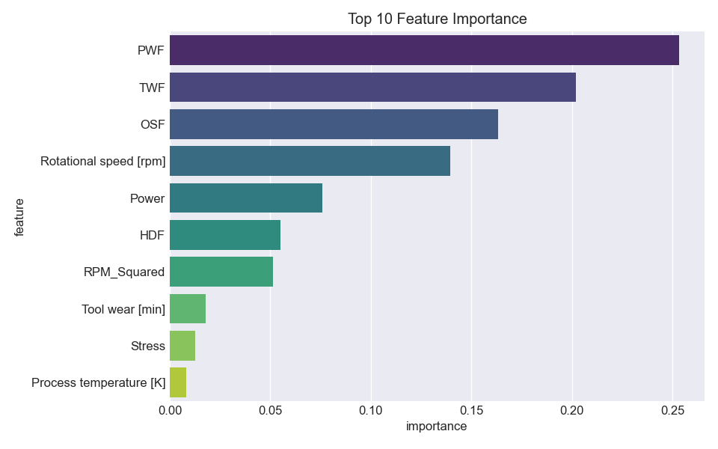
7.5 SHAP Analysis
Explains individual predictions and model interpretability.
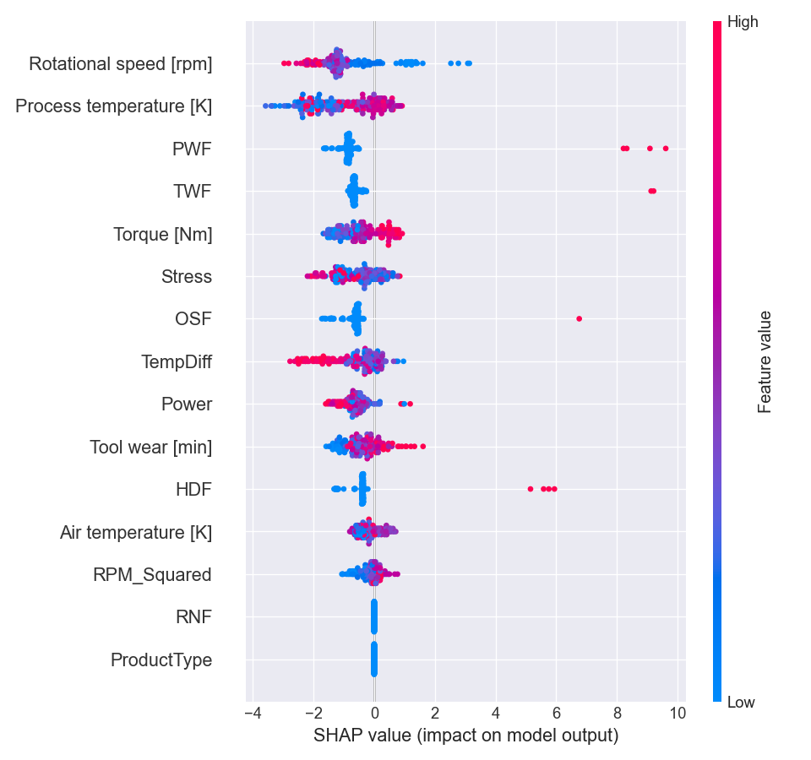

8. KEY INSIGHTS
- Mechanical stress-related features are most important for predicting failures
- Tool wear and torque are strong indicators of failure risk
- SMOTE significantly improves detection of rare failure cases
- XGBoost performs well for industrial predictive maintenance problems

9. MAINTENANCE STRATEGY
Based on model predictions:
Maintenance thresholds:
- Normal: Low failure probability
- Caution: Moderate risk
- Warning: High risk
- Critical: Immediate maintenance required
Recommendations:
- Schedule preventive maintenance during “Warning” phase
- Monitor machines with high torque and wear
- Use predictive alerts to reduce downtime
- Prioritize machines classified as high-risk

10. CONCLUSION
This project successfully demonstrates a machine learning-based predictive maintenance system using XGBoost and SMOTE. The model effectively handles class imbalance and provides accurate failure predictions.
The system can help industries:
- Reduce unexpected machine breakdowns
- Optimize maintenance scheduling
- Improve operational efficiency
- Reduce maintenance costs

11. FUTURE IMPROVEMENTS
- Integration with real-time IoT sensor data
- Deployment using Streamlit or Flask
- Use of LSTM for sequential time-series prediction
- Cloud-based monitoring system

